Deliverable 1

Team 19 :

Théo Dallet—Thuillier

Tom Patrzynski

Tom Laine

Table des matières

I. Context 1

II. Library 2

III. Functional dependency matrix 3

IV. Conceptual data model 4

V. Logical Data Model 5

VI. Physical Data Model 6

VII. Request 10

VIII. Conclusion 19

# Context

We are the company named DATA-X, within the framework of the last IPCC report, the Minister of Ecology contacted us to create a tool to store and query public data on air quality in major French cities.

# Library

To begin with we made a data dictionary which will be used to clarify all the data that will be useful to us later to make our conceptual data model.

We then decided to split our data to be able to make our future tables for the CMD and to put identifiers which will be useful later to be able to find our data :

# Functional dependency matrix

Following the library we made a functional dependency matrix which will be used to identify the dependencies between our identifiers and the rest of the data, this matrix will be useful for the creation of the CMD.

# Conceptual data model

A first design of the mcd included 9 tables allowing the different data to be distributed in a logical way:

Subsequently, a second approach to the MCD was created which facilitates its understanding and the creation of queries.

# Logical Data Model

The creation of the LDM using the JMerise application has made it possible to link all the tables, in particular thanks to the foreign keys that have appeared. There are also new tables that appeared when the cardinalities were maximum, i.e. '0.n', '1.n'.

# Physical Data Model

Description of the sensor table:

# Request

For the queries we used several things:

* The projection is used to display what we want at the end of the query.
* The restriction serves to select only what we have on data.

- A join that allows two tables to be linked by a common point (e.g. an identifier).

* The aggregate is used to use functions like min, max, average ( ** Min(),Max(), Count(),Avg()...).

1.List all the agencies

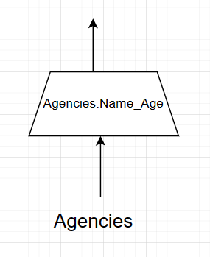

2.List all the technical staff of the Bordeaux agency

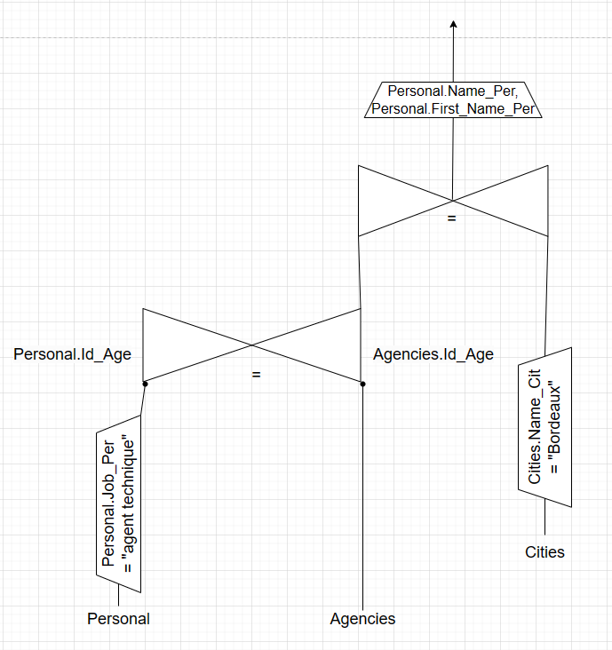

3.List the total number of sensors deployed.

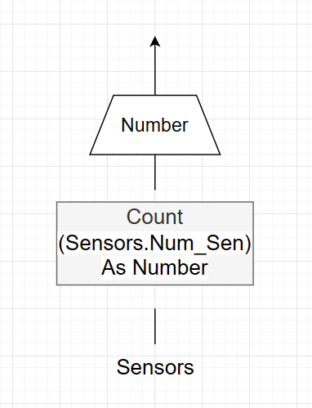

4.List the reports published between 2018 and 2022

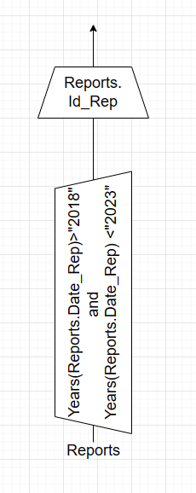

5.Calculate the total greenhouse gas emissions by region in 2020

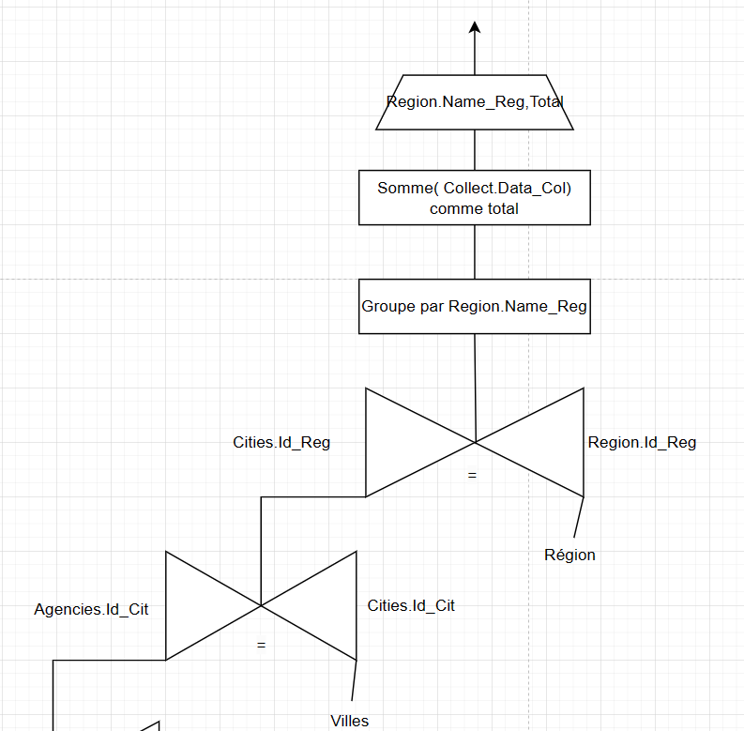

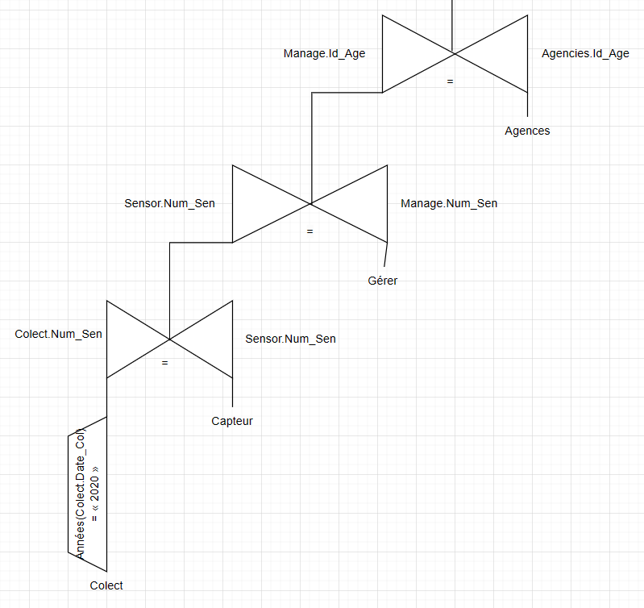

6.Display the most polluting sector of activity in Ile de France

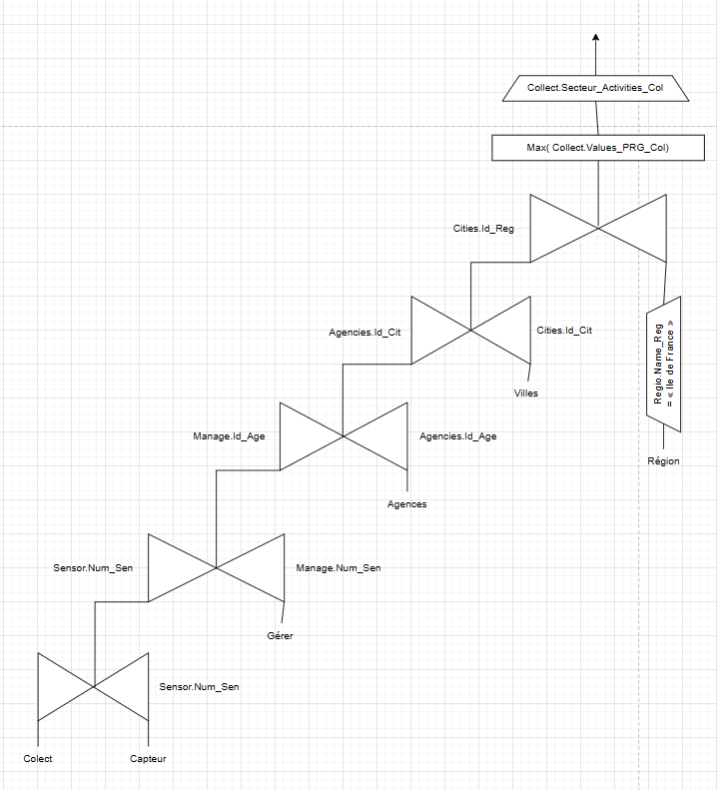

7. List the reports concerning NH3 emissions in chronological order.

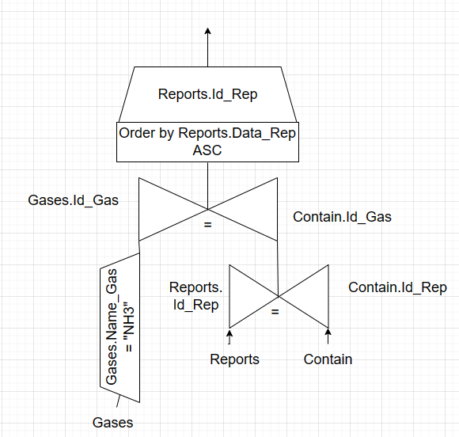

8.Give the names of the technical agents maintaining the sensors concerning the acidifying pollutants.

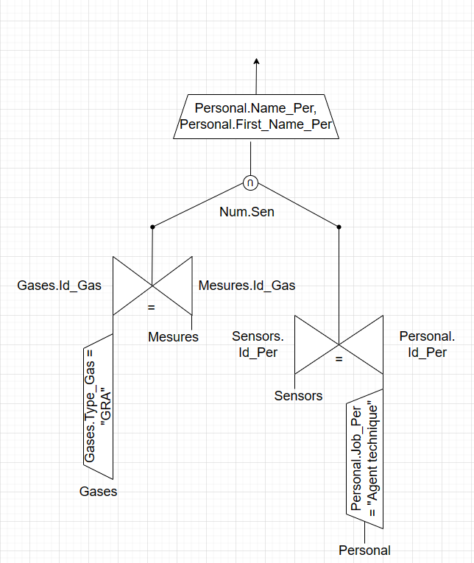

9. For each gas, give the sum of its emissions (in tons) in the Ile-de-France region in 2020.

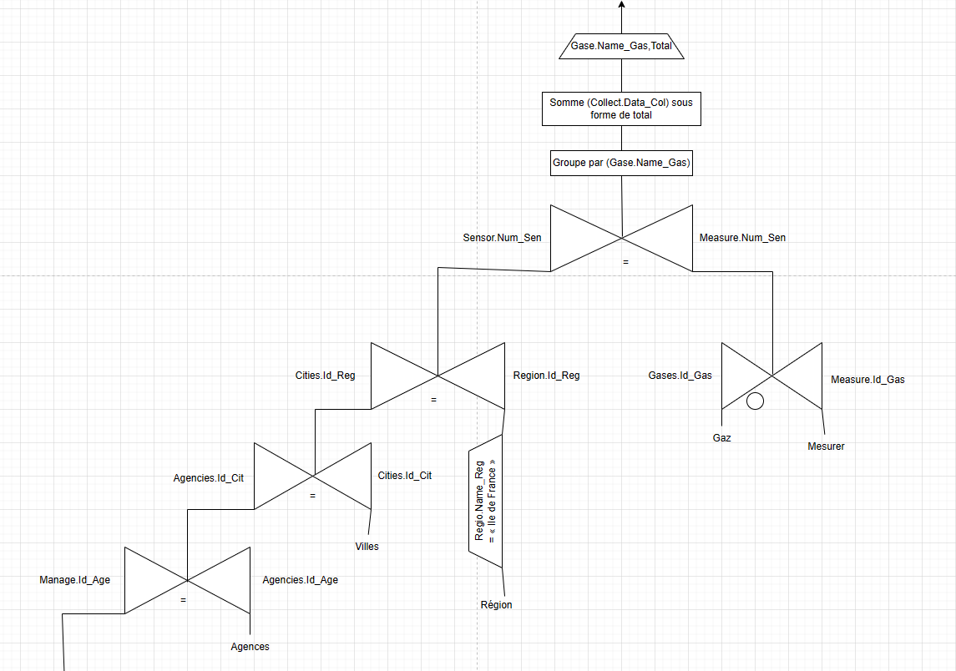

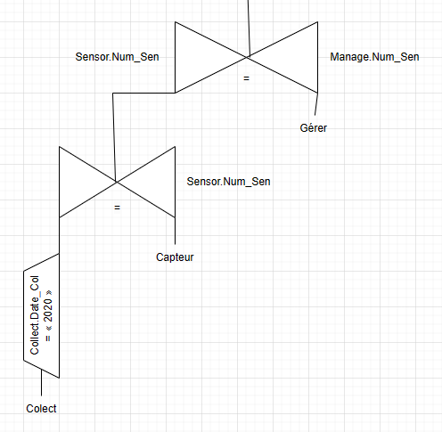

10. Give the productivity rate of the administrative agents of the Toulouse agency (according to the number of written reports and their seniority in the position)

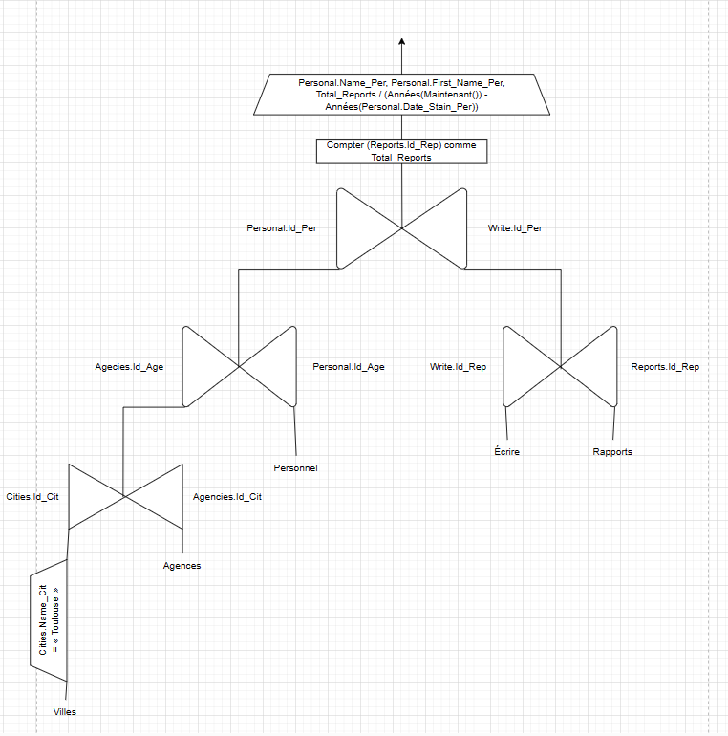

*

*

11. For a given gas, list the reports that contain data concerning it (it must be possible to give the name of the gas as a parameter)

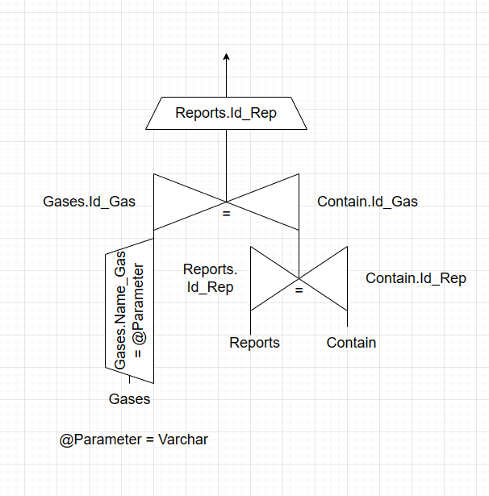

12. List the regions in which there are fewer sensors than agencies.

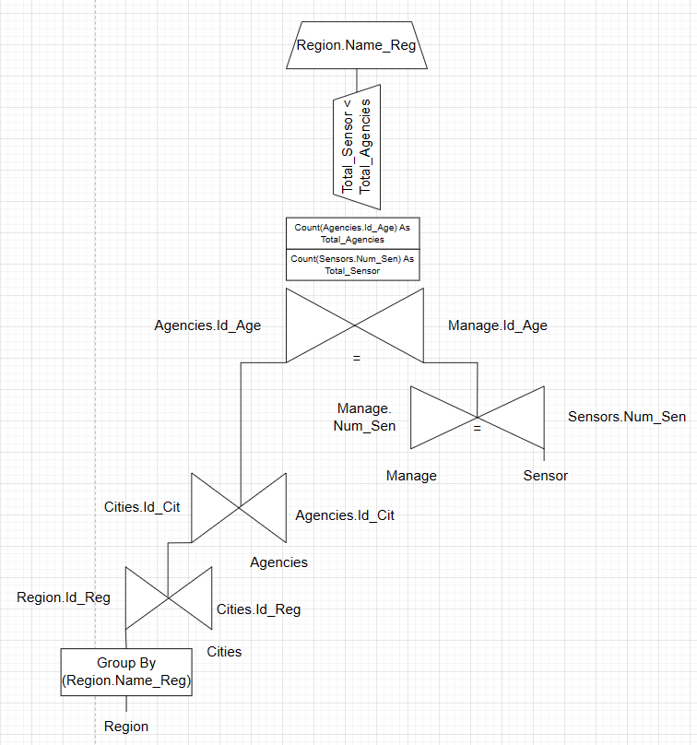

# Conclusion